Grazioso Salvare Animal Outcomes Dashboard
Project Description
The Grazioso Salvare Dashboard is an interactive web application designed to filter and display data on animal outcomes from the Austin Animal Center. The dashboard includes:
- Interactive filtering options for rescue types (Water, Mountain/Wilderness, Disaster/Individual tracking)
- Interactive Data Table displaying full outcomes data
- Pie Chart showing breed distributions
- Geolocation Map plotting outcome locations and an interactive map
These features allow Grazioso Salvare to quickly identify aniamls best suited for specific rescue operations.
Tools Used
- Python: Scripting and data manipulation
- Dash: Framework for building interactive web applications with python
- MongoDB: Database for storing and retrieving the Austin Animal Center outcomes dataset
- Plotly: Library for creating interactive charts and graphs
- Dash Leaflet: Used to render the interactive map component
- Pandas: Data manipulation and filtering before visualizing in charets and tables
MongoDB
MongoDB was chosen for its flexibility in handling large volumes of unstructured data. It allows easy storage of JSON documents and integrates smoothly with Python using the pymongo library.
Dash Framework
Dash was selected for building the interactive web application because it provides a simple but powerful framework for developing dashboards, integrates seamlessly with Ploty for real-time charting, and it also supports callbacks that allow dynamic updates to tables, charts, and maps when filters are applied.

Step Taken
- Setup MongoDB and Python Environment
  - Imported the dataset into MongoDB with mongoimport
  - Connected to the dataset using pymongo
- Develop CRUD Operations
  - Implemented in AnimalShelter.py to handle database interactions
- Build Dashboard Layout
  - Created interactive filters, data table, pie chart, and geolocation map
- Implement Callbacks
  - Added interactivity so charts and tables update automatically when a filter option is selected
- Testing and Debugging
  - Verified that each component displayed data correctly
  - Resolved any syntax errors, and pie chart legend overlaps
Challenges and Solutions
I encountered several challenges while completing this project. My main challenge was implementing the interactive filtering. Some filters did not update the charts as I expected, I resolved this by refining the MongoDB queries and ensuring callbacks returned properly formatted data. I also discovered a few misaligned elif statements that were causing issues as well. Another issue I encountered was that the pie chart legend was overlapping with my pie chart which was making the chart unreadable. I fixed this by moving the legend to the right of the pie chart.

Screenshots
No Filter
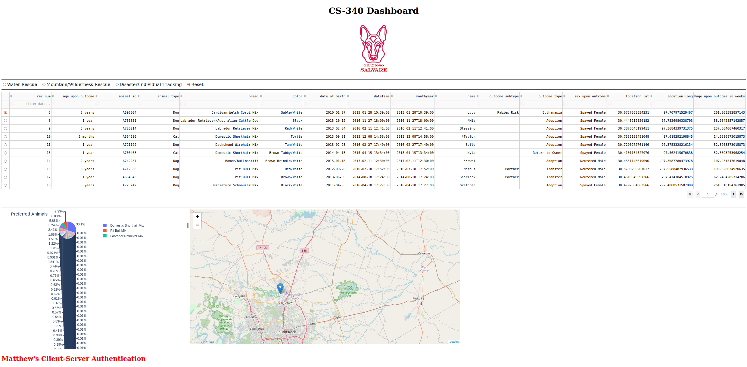
Water Rescue
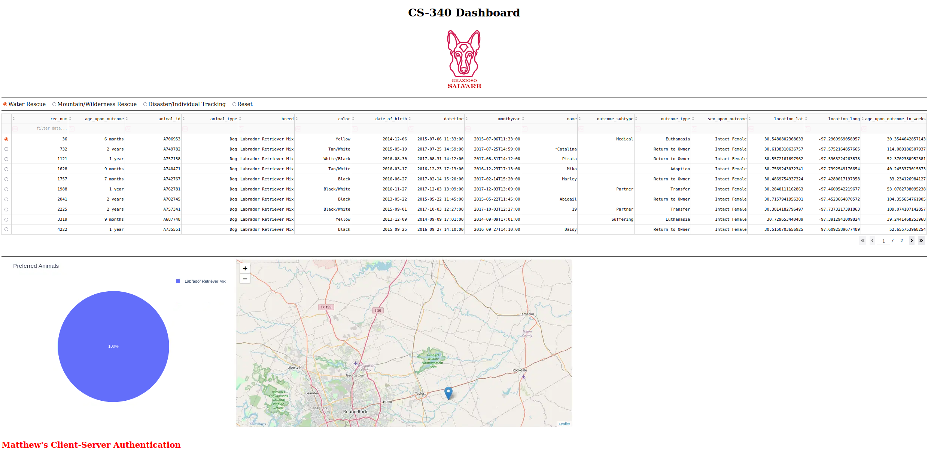

Mountain/Wilderness Rescue
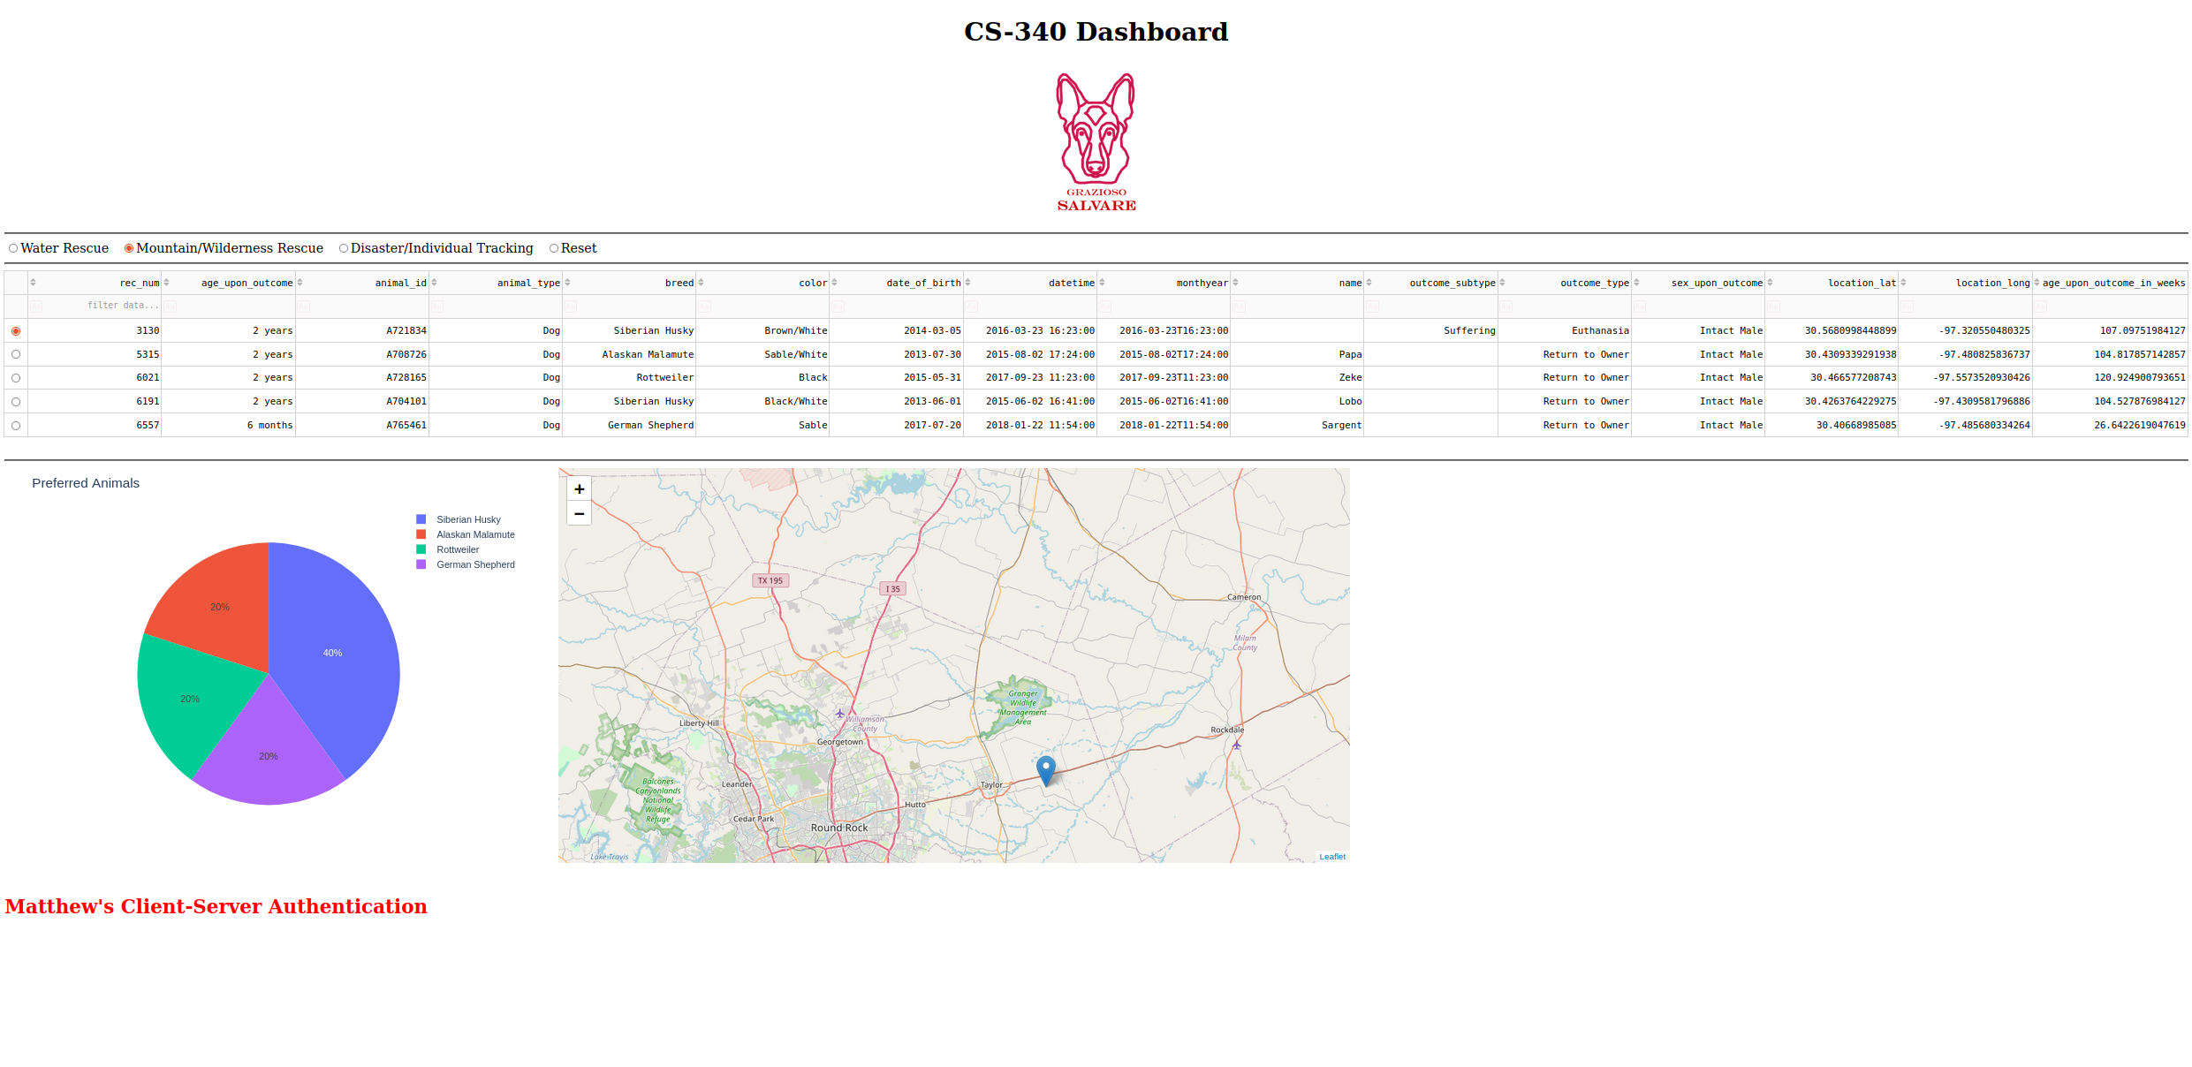
Disaster/Individual Tracking Rescue
